My 5 questions are:
- What part of the game did you enjoy the most?
- What part of the game did you enjoy the least?
- Did you encounter any bug/issues while playing through the game?
- Was any part of the game vague or unclear?
- Overall how was your experience with the game?
I had 4 people test my game, but only 3 actually filled out the survey
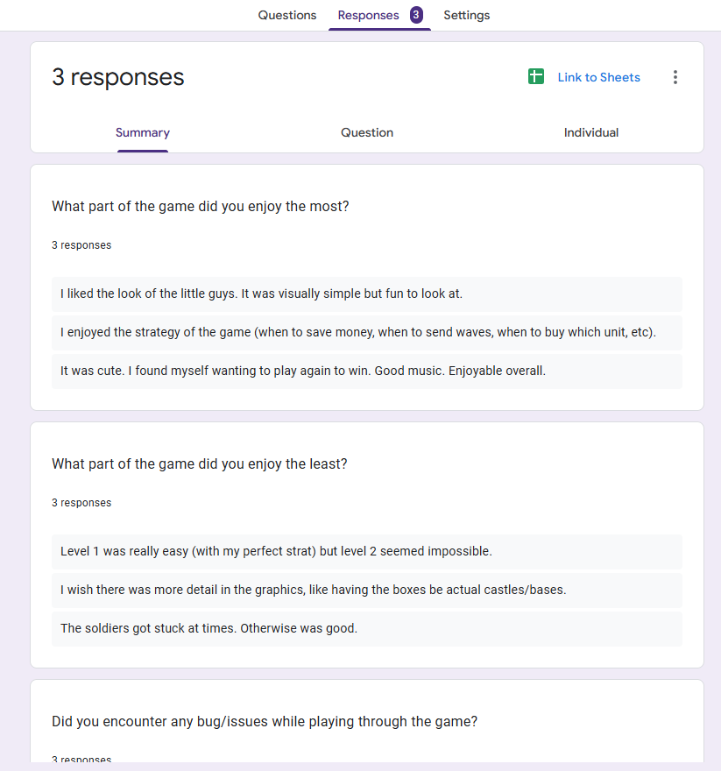
For the answers to the first question, the things people tended to enjoy the most were the media in the game rather than the gameplay itself. There were several issues that made it harder to enjoy the game, namely units getting stuck. Also, while most testers were able to understand the mechanics intuitively, the only that wasn’t made it obvious I put literally no explanations anywhere, so if someone doesn’t intuitively get the mechanics they would figure it out. Everyone who played it said they enjoyed it, but there is likely a bit of bias from the fact they are all my friends or family, and they know I will see their answers, even if they are anonymous.

For the assisted summary, I used ChatGPT to help generate a summary from the survey answers.
https://chatgpt.com/c/692d234a-f3e0-8326-8ac7-eaa817107238

